Title in Bold, 16-Point Type, Centered, Title Case

Author name(s) [10-point type, centered, bolded]
Author affiliation and full address (8-point type, centered, italicized)

Abstract: Your abstract should be an explicit summary of the paper, stating the problem, the major results, and conclusions. Indent left and right margins 0.6 cm, justify the paragraph [10-point font] Up to 40 words.

The use of this style guide is critical to provide a consistent appearance. Please use 10-point Arial font, and do not use hyphens at the end of a line. A5 format is designated, please use the moderate margins: 2.54 cm top margin 2.54 cm bottom margin, 1.91 cm left margin, and 1.91 cm right margin.
The paper can run up to maximum two pages. No more than two figures should be included.
Figures and illustrations should be incorporated directly into the manuscript, as centered and located inside paper margins. Text should not wrap around figures or tables; table and figure captions (9-point font) should be centered below figure or table. Both should appear as close as possible to where they are mentioned in the main text.
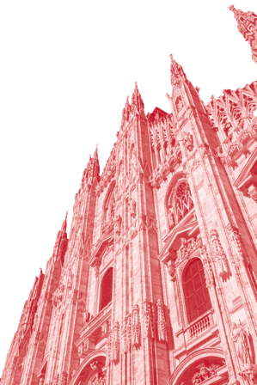
Fig.1 | Sample figure, preferred style for labeling parts a, b, c.
References should appear at the end in the order in which they are referenced in the body of the paper. The references should be in 9-point font and aligned left. Within the main text, references should be designated by a number in brackets [1], and they should be followed by a comma or period [2]. Two references cited at once should be included together [3,4], separated by a comma, while three or more consecutive references by a dash [1–4].

Contacts:
Nome Cognome (email)
Nome Cognome 2 (email)
References
[1] A. Surname, “Title,” Journal Abbreviation Vol, pages (year).

